敬邀參與
「國外儲能系統之發展與應用」國際專家諮詢會
敬啟者 您好：
電力為國家產業發展及國民生計關鍵要素之一，影響電力負載之因素包括自然驅動因素、經濟驅動因素、節電管理、新電力科技及能源替代等眾多因素，為使我國長期電力負載預測之方法論、考量變數及評估結果更為周延及合理，希冀藉此瞭解國際間各電力公司對電力供需規劃之作法。
近年，政府提出能源轉型政策，積極擴大再生能源設置，為因應未來大量再生能源併網之衝擊，及充分有效利用自有資源，發展電網級儲能系統，降低我國未來系統發展可能面臨之風險與挑戰。2018年電力供需計畫團隊邀請日本能源經濟研究所 (The Institute of Energy Economics, Japan - IEEJ)，在再生能源電網整合及儲能系統皆有相關研究經驗的柴田善朗研究員，針對日本電力市場之儲能設備未來發展及電動運輸系統規劃，以及日本電力市場所遇到之挑戰，向與會來賓分享研究成果與心得；國內亦邀請台電公司電力調度處吳進忠處長，為各位說明台灣電力系統未來在大量再生能源併網下，可能遇到的風險和挑戰。中日相互經驗交流與討論，可作為我國未來電力供需規劃之規劃參考。
本年度（2019）財團法人台灣綜合研究院擬延續儲能系統發展議題，規劃於11月29日及12月6日召開國際專家諮詢會議，主題訂為「國外儲能系統之發展與應用」，特邀請德州大學阿靈頓分校(University of Texas at Arlington, USA)的李偉仁教授及日本名城大學(Meijo University)的益田泰輔教授，針對美國及日本的儲能系統之技術與因應發展情勢進行相關演講。依憑兩位國外專家學者的豐富研究經驗，與現場來賓經驗交流討論下，可藉此強化我國儲能系統發展經歷，提供政府後續進行電源規劃之參考。
素仰 貴機構、公司、暨專家於電力領域之專業，誠摯邀請您共同參與2019年「國外儲能系統之發展與應用」國際專家諮詢會議，敬請撥冗 賜教。
敬頌
時祺

財團法人
台灣綜合研究院
敬邀
「國外儲能系統之發展與應用」
國際專家諮詢會 第一場議程

時間：108年11月29日（星期五）
地點：集思北科大會議中心_艾爾法廳

（台北市大安區忠孝東路三段1號億光大樓3F）
2019「電力穩定供應策略與規劃」國際專家諮詢會
「國外儲能系統之發展與應用」
“The Planning and Strategy of Stable for Power Supply”
International Experts Roundtable
2019年11月29日
Time | Description
09:30~10:00  (30 mins) | Registration報 到
10:00~10:10  (10 mins) | Opening Remarks主席致詞、介紹與會來賓
10:10~10:20  (10 mins) | Distinguished Guest's Remark貴賓致詞、Photo合照
10:20~12:00  (100 mins) | 《專家論壇一》  主持人：籃宏偉 副總（台電公司前副總經理）  主講人：德州大學阿靈頓分校 李偉仁教授  題目: Battery Storage Technologies & Their Potential Applications in the Power Systems （儲能電池技術與應用電力系統之潛力）  與談人：王人謙 副所長（工研院綠能與環境研究所 副所長）
12:00~13:30  (90 mins) | Lunch午餐及休息時間
13:30~15:10  (100 mins) | 《專家論壇二》  主持人：李漢申 總督導（台電公司前總經理/台灣綜合研究院 總督導）  主講人：德州大學阿靈頓分校 李偉仁教授  題目：Applications of the Energy Storage Systems in the US  （美國儲能系統之應用）  與談人：吳進忠 處長（台電公司電力調度處 處長）
15:10~15:30  (20 mins) | Short break中場休息
15:30~16:30  (60 mins) | 《圓桌綜合論壇》  主持人：吳再益 院長（台灣綜合研究院 院長）  與談人：李偉仁 教授（德州大學阿靈頓分校 教授兼系主任）  籃宏偉 副總（台電公司前副總經理）  王人謙 副所長（工研院綠能與環境研究所 副所長）  吳進忠 處長（台電公司電力調度處 處長）
16:30 | 賦歸
註：1.演講以中文進行，簡報資料則為英文。
2.主辦單位保留調整本活動內容(例如議程調整)之權利。
講者簡介
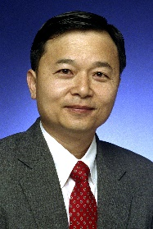
Biography: Wei-Jen Lee, PhD, PE; Professor and Director; Energy Systems Research Center. The University of Texas at Arlington. wlee@uta.edu
Professor Lee received the B.S. and M.S. degrees from National Taiwan University, Taipei, Taiwan, R.O.C., and the Ph.D. degree from the University of Texas, Arlington, in 1978, 1980, and 1985, respectively, all in Electrical Engineering.
In 1986, he joined the University of Texas at Arlington, where he is currently a professor of the Electrical Engineering Department and the director of the Energy Systems Research Center.
He has been involved in the revision of IEEE Std. 141, 339, 551, 739, 1584, and 3002.8 development. He is the President Elect of the IEEE Industry Application Society (IAS) and an editor of IEEE Transactions on Industry Applications and IAS Magazine. He is the project manager of IEEE/NFPA Collaboration on Arc Flash Phenomena Research Project.
Prof. Lee has been involved in research on Utility Deregulation, Renewable Energy, Arc Flash Hazards and Electrical Safety, Smart Grid, MicroGrid, Industrial Internet of Things (IIoT) and Virtual Power Plants (VPP), AI for Load, Price, and Wind Capacity Forecasting, Power Quality, Distribution Automation, Demand Response, Power Systems Analysis, Short Circuit Analysis and Relay Coordination, Distributed Energy Resources, Energy Storage System, PEV Charging Infrastructure Design, AMI and Big Data, On Line Real Time Equipment Diagnostic and Prognostic System, and Microcomputer Based Instrument for Power Systems Monitoring, Measurement, Control, and Protection. He has served as the primary investigator (PI) or Co-PI of over one hundred funded research projects with the total amount exceed US$16 million dollars. He has published more than one hundred and sixty journal papers and two hundred eighty conference proceedings. He has provided on-site training courses for power engineers in Panama, China, Taiwan, Korea, Saudi Arabia, Thailand, and Singapore. He has refereed numerous technical papers for IEEE, IET, and other professional organizations.
Prof. Lee is a Fellow of IEEE and registered Professional Engineer in the State of Texas.

- 演講摘要
Battery Storage Technologies & Their Potential Applications in the Power Systems

ABSTRACT
Electrical power infrastructures are changing dramatically around the globe due to smart grid initiatives, the establishment of renewables and the resulting distributed nature of creating electricity, the need for independent microgrids to ensure grid reliability, new demands from end users, the need to reduce greenhouse gas emissions, as well as the capability to accommodate mixed energy resources. As a result, the power network faces great challenges in generation, transmission and distribution to meet new and many times unpredictable demands of providing coherent electricity supply. Battery Energy Storage (BES) has been considered a game-changer with a number of technologies that have great potential in meeting these challenges.
However, the wide variety of options and complex performance matrices can make it difficult to appraise specific BES technology for particular applications. This presentation intends to contribute information that will give a Smart Grid user a clearer picture of the state-of-the-art electrochemical technologies available, and where they would be suited for integration into a power generation and distribution system.
Energy Storage Systems Development in the US
ABSTRACT
One of the distinctive characteristics of the electric power sector is the requirement of second -by-second balancing of generations and loads to maintain the system frequency and voltage within relative tight range. The demand for electricity fluctuates throughout the day and the supplies are difficult to control especially with high penetration level of renewable energy. Develop technologies to store surplus or lower cost electrical energy and makes it available to meet demand whenever needed to minimize the operation cost would represent a major breakthrough in the power industry. The suitability of a storage technology is determined primarily by its power and energy capacity and the rate at which these can be stored and delivered. Other characteristics to consider are cost, round-trip efficiency, cycle life, calendar life, safety, reliability, maintenance requirements, their impact on the environment, and ramp rate (how fast the technology can respond to a command).
This presentation covers the pros and cons of different energy storages technologies such as pumped storage, superconducting magnetic energy storage (SMES), fuel cell, compressed air energy storage (CAES), flywheels, and battery storages at the grid level applications.

「國外儲能系統之發展與應用」
國際專家諮詢會 第二場議程

時間：108年12月6日（星期五）
地點：公務人力發展中心福華國際文教會館_103會議室

（台北市新生南路三段30號）
2019「電力穩定供應策略與規劃」國際專家諮詢會
「國外儲能系統之發展與應用」
“The Planning and Strategy of Stable for Power Supply” International Experts Roundtable
2019年12月6日
Time | Description
13:30~14:00  (30 mins) | Registration報 到
14:00~14:10  (10 mins) | Opening Remarks主席致詞、合照
14:10~15:40  (90 mins) | Speaker：日本名城大學 益田泰輔教授 (Taisuke Masuta)  Title: Development of Japanese smart grid control and operation  （日本智慧電網運作之發展）
15:40~16:00  (20 mins) | Short break中場休息
16:00~16:40  (40 mins) | 《圓桌綜合論壇》  主持人：吳再益 院長（台灣綜合研究院 院長）  與談人：益田泰輔 教授（日本名城大學 電氣電子工程系 教授）  林法正 教授（中央大學電機工程學系 教授/台電常務董事）  陳朝順 教授（中山大學電機工程學系 講座教授）
16:40 | 賦歸
註：1.演講及簡報資料為英文，現場備口譯人員逐段進行口譯說明。
2.主辦單位保留調整本活動內容(例如議程調整)之權利。

- 講者簡介
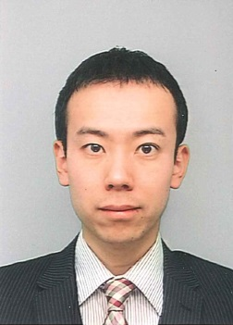
Biography: Masuta Taisuke, PhD and Prof.,
The University of Meijo at Nagoya. Dept. of Electrical and Electronic Engineering, Faculty of Science and Technology masuta@meijo-u.ac.jp
Taisuke Masuta received his Ph. D in Electrical Engineering and Information Systems at The University of Tokyo with specialization in power system engineering. He worked at Tokyo Electric Power Co. before his doctoral course. He has held various research and teaching positions in National Institute of Advanced Industrial Science and Technology (AIST), The Institute of Applied Energy (IAE), Hosei University, and Chiba University before joining the Department of Electrical and Electronic Engineering at Meijo University in Japan in 2016. He is the co-authors of numerous conference and journal papers. One of the papers, “Supplementary load frequency control by use of a number of both electric vehicles and heat pump water heaters” has been cited more than 200 times according to Google Scholar. He has been a member of Program Committee and Investigating R&D committee of IEEJ. Since 2014, he has been working as a unit leader of a national big project tiled “System Theory for Harmonized Power System Control Based on Photovoltaic Power Prediction” granted by JST CREST, which is one of the largest Japanese governmental research funds.
His recent research interests include the future power system planning, operation, and control with high renewables (e.g., wind and photovoltaic power generation) and non-conventional controllable resources (e.g., battery energy storage systems, demand response). Specific research topics include scheduling of batteries and conventional generators based on renewable forecasts, tertiary control by batteries and conventional generators by optimal power flow calculation (OPF), and distribution system control with conservation voltage reduction (CVR) and battery charge/discharge.

- 演講題綱
- Introduction
- History and development of smart grid
- Instruction of Japanese power systems (past, current, and future)
- R&D of Japanese smart grids (main contents especially on battery storage application)
- Conclusion

報名回函
報名網址連結：「國外儲能系統之發展與應用」國際專家諮詢會
(請按上方報名網址填寫資料，或填寫下方回函內容，傳真至：02-2778-3500)
2019年「國外儲能系統之發展與應用」國際專家諮詢會
姓名 |  | 英文姓名
單位  名稱 |  | 英文單位  名稱
職稱 |  | 英文職稱
聯絡電話
E-mail
聯絡地址
報名場次 | □11/29 □12/6 □皆無法出席
用膳調查 | 11/29是否用膳？ □是 □葷 □素  □否
註：1. 敬請於108年11月20日（三）前回覆，以便安排席次及準備資料。
2. 名額有限，請洽詢聯絡人。

聯絡人：
台灣綜合研究院 彭裕芸小姐/  電話：02-2778-3600 轉 123  傳真：02-2778-3500  E-mail：yuyun.peng@tri.org.tw | 台灣綜合研究院 黃珮瑜小姐/  電話：02-2778-3600 轉 112  傳真：02-2778-3500  E-mail：peiyu.huang@tri.org.tw
台灣綜合研究院 江孟勳先生/
電話：02-2778-3600 轉 108
傳真：02-2778-3500
E-mail：menghsun.chiang@tri.org.tw

交通資訊：
- 集思北科大會議中心_艾爾法廳
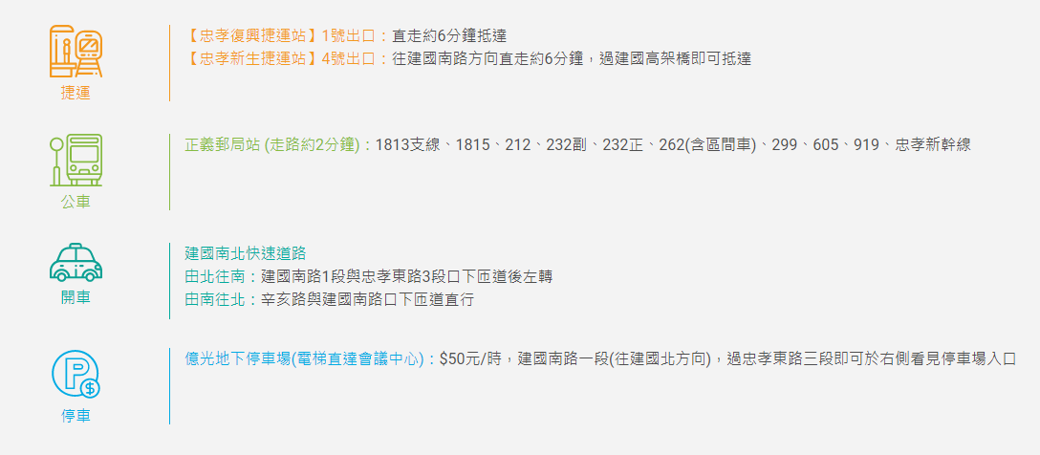
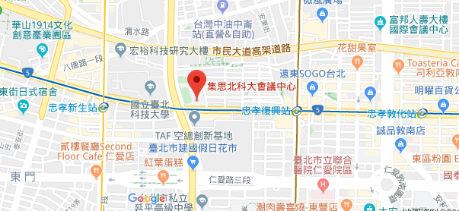
- 公務人力發展中心福華國際文教會館（會議時間：12/6）
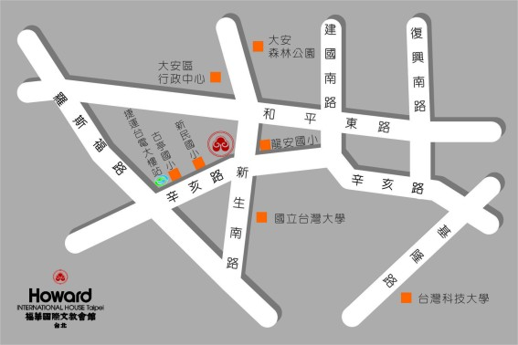

公車
龍安國小-- 52,253,280,284,290,311,505,907, 0南,指南1
大安森林公園-- 3,15,18,52,72,74,211,235,237, 278,295,626
和平新生路口-- 253,280,290,311,505,642,0南, 指南1,指南5
溫州街口-- 3,15,18,74,235,237,254,278,295, 907,291,672
公務人力發展中心-- 52,253,280,284,290,291, 311,505,642,907,0南,指南1

捷運
捷運台電大樓站2號出口，出站左轉沿辛亥路步行約10~15分鐘至辛亥路新生南路口左轉

